

**Software User’s Manual**

**Hanoi, August 12th, 2020**

**Table of contents**

**Chapter 6: Software User’s Manual** 2

**1.User’s guide**

**1.1. Candidate**

*1.1.1. Menu*

*1.1.2. Search job*

*1.1.3. List jobs*

*1.1.4. Job positions*

*1.1.5. Working environment*

*1.1.6. What did FPT Education people say?*

*1.1.7. Apply job*

*1.1.8. Recruitment process*

*1.1.9. Edit CV*

*1.1.10. Take quiz*

**1.2. Login**

**1.3. Super Admin**

*1.3.1. Account management*

*1.3.2. Location management*

*1.3.3. Unit management*

*1.3.4. Career management*

*1.3.5. Config email management*

*1.3.6. Question management*

*1.3.7. Question group management*

*1.3.8. Quiz management*

*1.3.9. Log management*

**1.4. HR Staff**

*1.4.1. Job management*

*1.4.2. CV management*

*1.4.3. Error email management*

# 

**Chapter 6: Software User’s Manual**

**1. User’s guide**

**1.1. Candidate**

***1.1.1. Menu***



*Header of home page*

“Trang chủ” : Display home page of FERS.

“Về chúng tôi” : Give information about history of FPT Education.

“Vị trí tuyển dụng” : Redirect to list of all jobs that are in recruitment need at FPT education.

“Gia nhập cùng chúng tôi” : Popup a modal dialog for users to register potential candidates

“Tin tức” : Redirect to news page of FPT Education.

“Liên hệ” : Redirect to contact page of FPT Education.

***1.1.2. Search job***

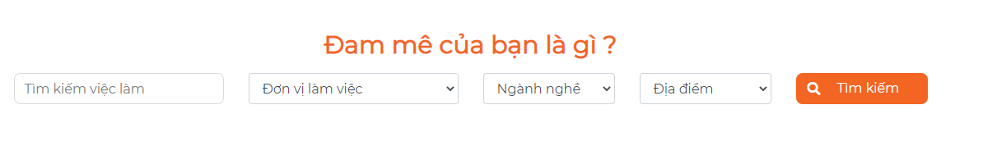

*Search bar*

Fill the condition you want to find and click the “Tìm kiếm” button. System will redirect to list jobs that are being recruited at FPT Education with the condition you want.

For example : Search job with title “Giáo viên STEM” and career “Giảng viên/Giáo viên” will return job based on condition search.

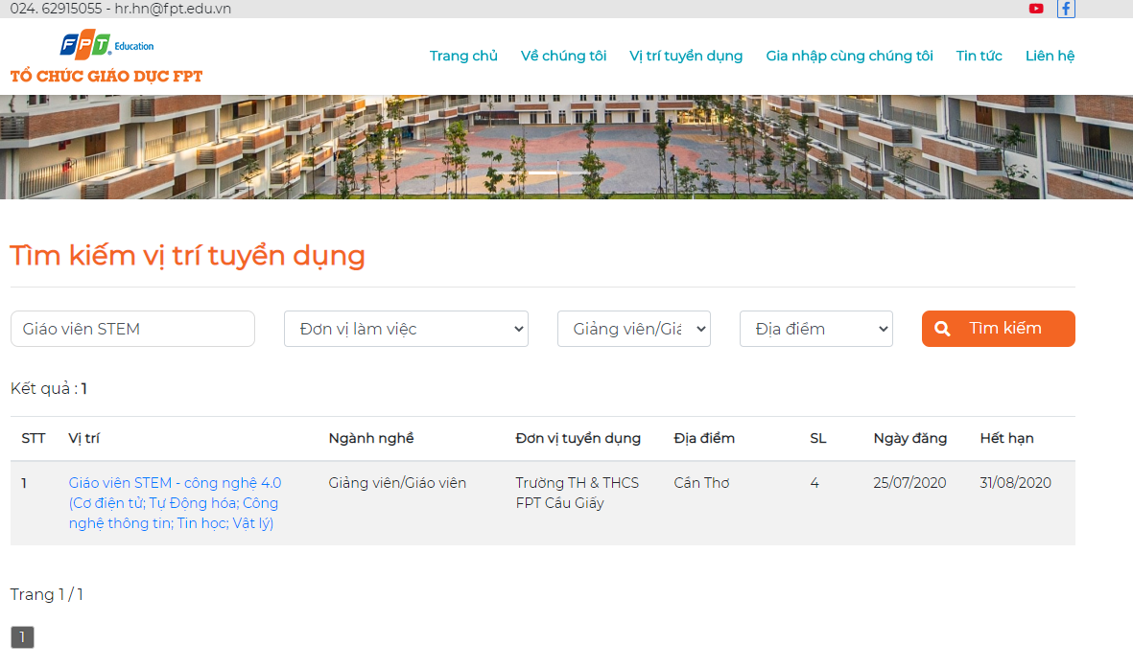

*List jobs page*

**1.1.3. List jobs**

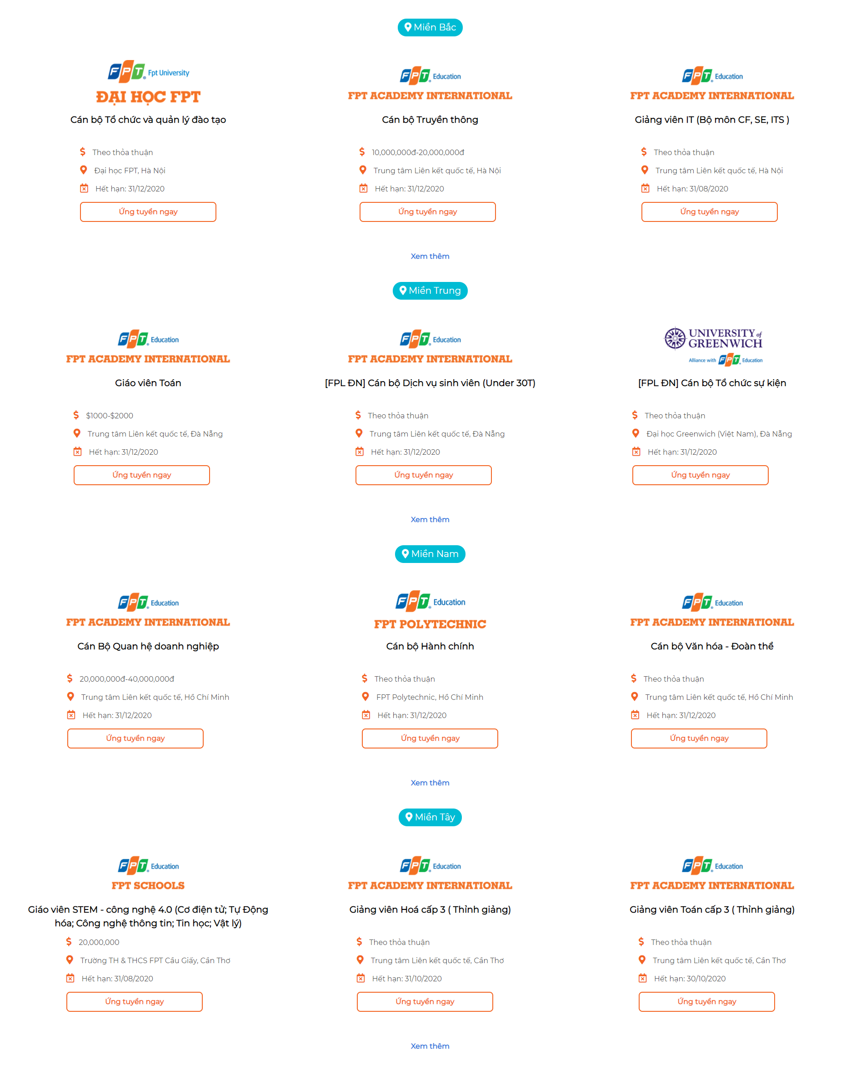

*Highlight jobs of regions*

That part displays jobs in each region on the home page, max is 3 jobs of each region. We have 4 regions in the system (Miền Bắc, Miền Trung, Miền Nam, Miền Tây). If you want to see more jobs in each region. Click the “Xem thêm” button, the system will redirect to a list of jobs in that region.

For example, I want to see all jobs of “Miền Bắc” region, I click “Xem thêm” of “Miền Bắc” region and the result is all jons of “Miền Bắc” (Having 3 jobs).

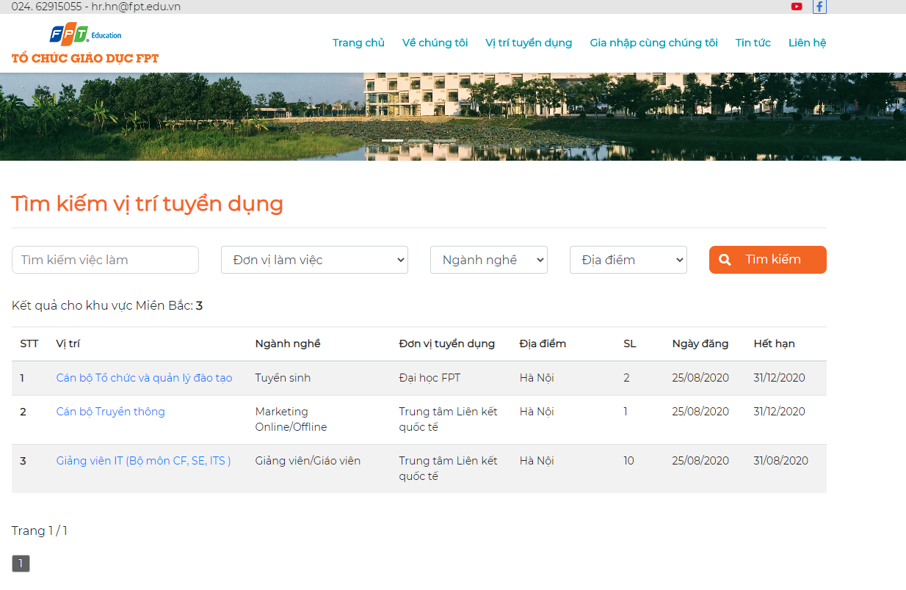

*Jobs displayed by a region*

**1.1.4. Job positions**

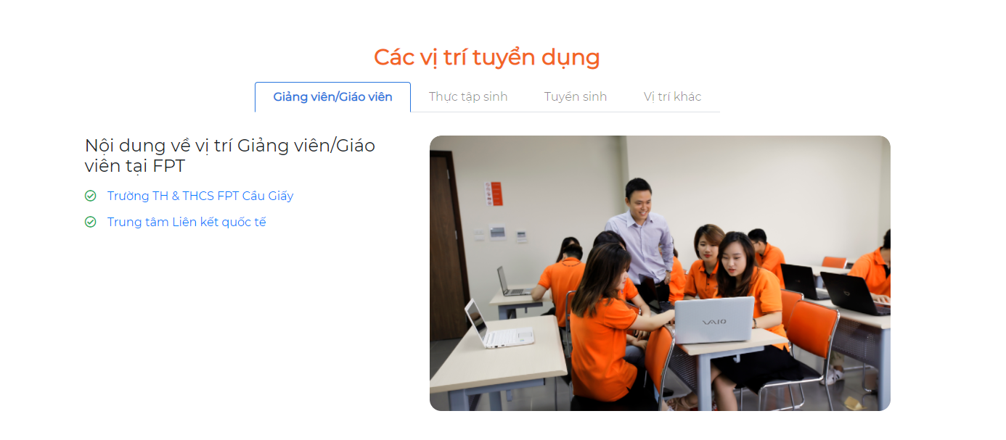

*Hot job positions and recruitment units*

This part is a description of a tab which has jobs. We device into 4 tab : “Giảng viên/Giáo viên”, “Thực tập sinh”, “Tuyển sinh”, “Vị trí khác”. In each tab, we will show all units have jobs in that position. If we click to each unit, we will show all jobs in this unit.

For example, in tab “Giáo viên/Giảng viên”, we have two units have jobs about “Giáo viên/Giảng viên” : “Trường TH & THCS FPT Cầu Giấy” and “Trung tâm Liên kết quốc tế”. When I click to “Trường TH & THCS FPT Cầu Giấy”, the system will show all jobs in this unit.

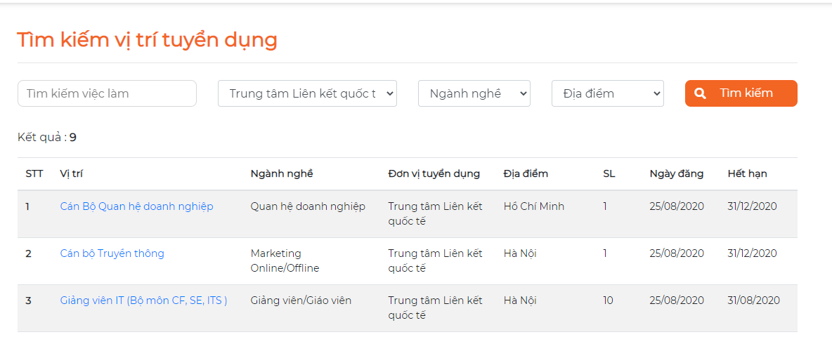

**1.1.5. Working environment**

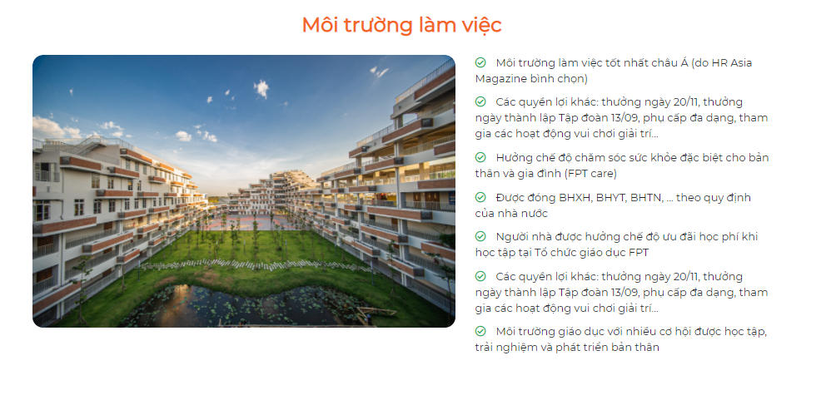

*Information about working environment of FPT Education*

This part describes the working environment in FPT Education, if click to image, the system will redirect to a detail description page.

**1.1.6. What did FPT Education people say?**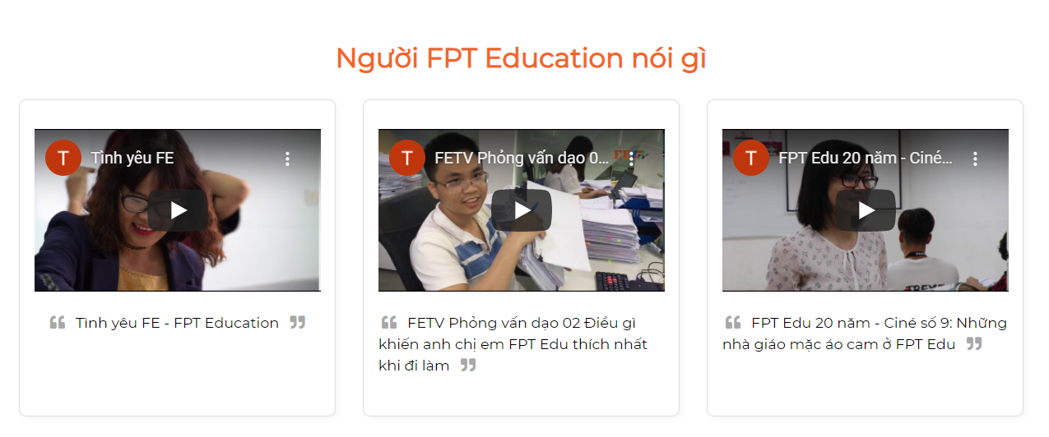

*Reviews about FPT Education*

This part gives some video about something that FPT Education people said. You can click each video to watch.

**1.1.7. Apply job**

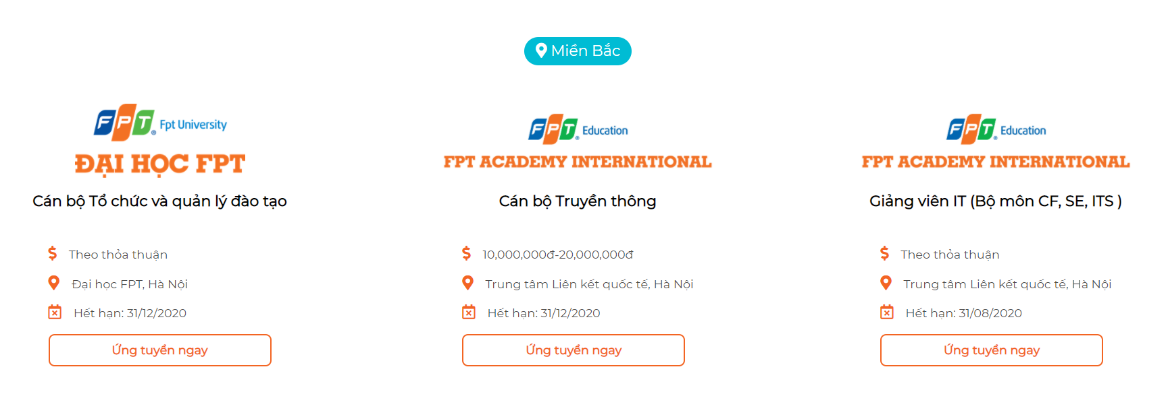

When you want to apply a job, you can click the “Ứng tuyển ngay” button of each job. The system will show a popup with 2 choices : “Có CV” and “Đã có CV”.

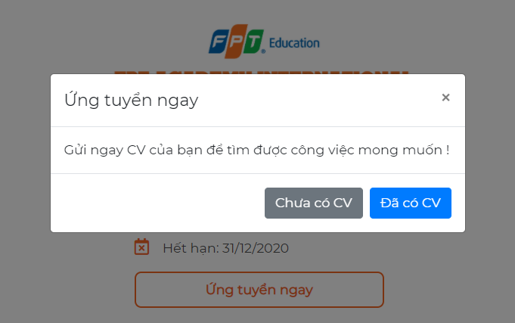

*Confirmation dialog box*

If you don’t have a CV, click the “Chưa có CV” button, the system will show a form suitable for you to fill in.

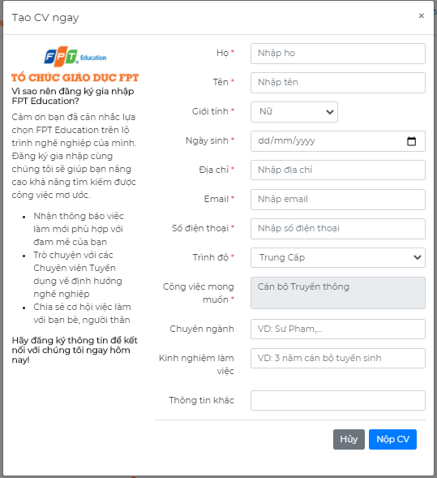

*Create CV modal dialog*

If you have a CV, click the “Đã có CV” button, the system will show a form suitable for you to fill in.

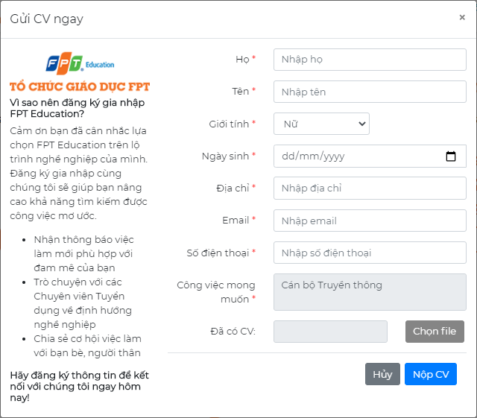

*Upload CV modal dialog*

Fields validation :

* With field have red symbol (*), you cannot leave it blank.
* In the field “Ngày sinh”, you must choose a date that is less than or equal to the current date.
* Phone number max length is 11 number.
* If you upload a CV file, the size of the file must be less than or equal 4MB.

Then, click the “Nộp CV” button to submit the form and the system will send a mail to you to confirm about receiving your CV.

If you don’t want to apply for a job but are still in contact with the recruitment system, you can register a CV to the system with your expected job by click “Gia nhập cùng chúng tôi” in menu tab or click the “Đăng ký” button in the bottom of page. The system will show a form for you to register.

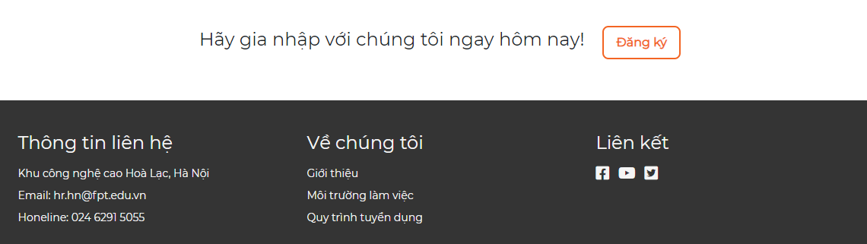

*Register potential candidate button*

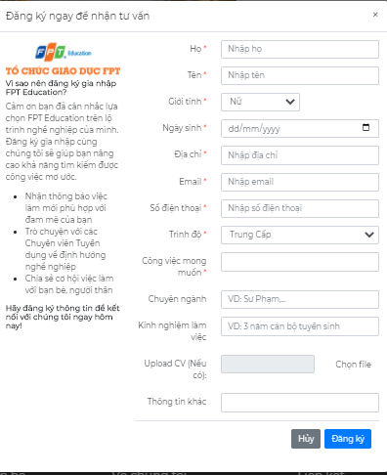

Fields validation :

* With field have red symbol (*), you cannot leave it blank.
* In the field “Ngày sinh”, you must choose a date that is less than or equal to the current date.
* Phone number max length is 11 number.
* If you upload a CV file, the size of the file must be less than or equal 4MB.

Then, click the “Đăng ký” button to submit the form and the system will send a mail to you to confirm about receiving your CV.

**1.1.8. Recruitment Process**

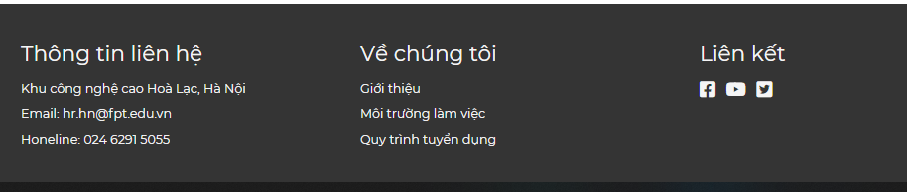

*Footer of FERS site*

When you click to “Quy trình tuyển dụng” on the footer, the system will redirect to recruitment process. This page have two part:

* Recruitment process: An image of the job recruitment process and steps at FPT Education
* Profile: Required documents and procedures if you are admitted to FPT Education

**1.1.9. Edit CV**

After successfully applying/registering potential candidates for a job, candidates will receive an email with a link allowing them to edit their CV.

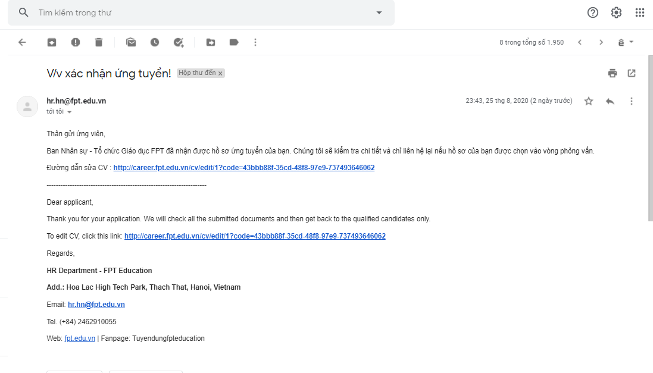

*Email notification of successful application*

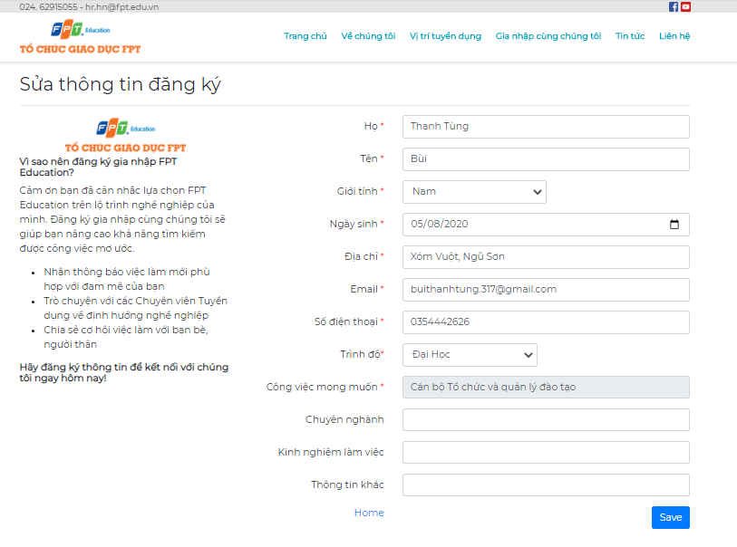

*Edit CV page*

**1.1.10. Take quiz**

After applying for a job successfully, Candidate’s CV will be stored in the system. Once HR Staff click send link quiz for the candidate, an email will be sent to the candidate, including the link of the quiz.

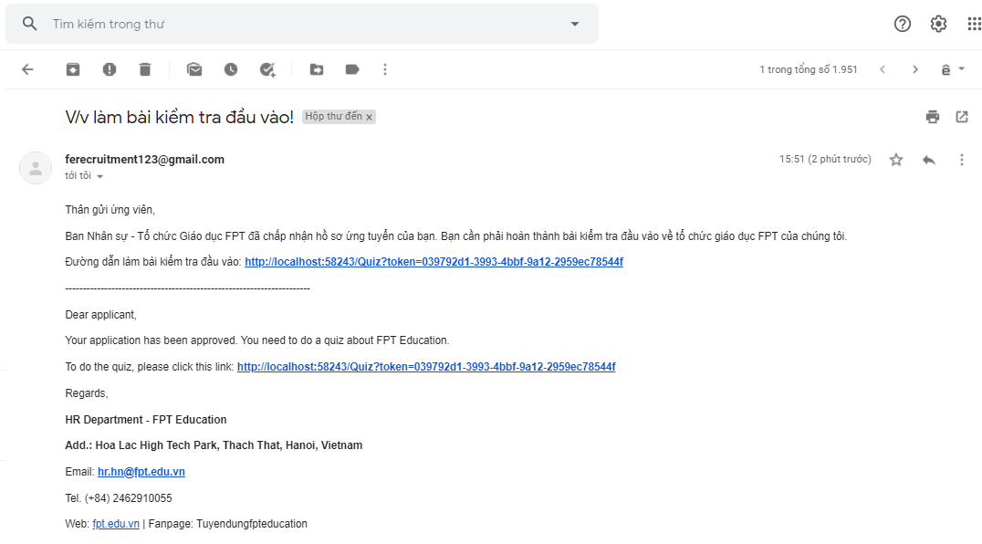

*Email quiz link*

Candidate will have 40 minutes to complete the quiz

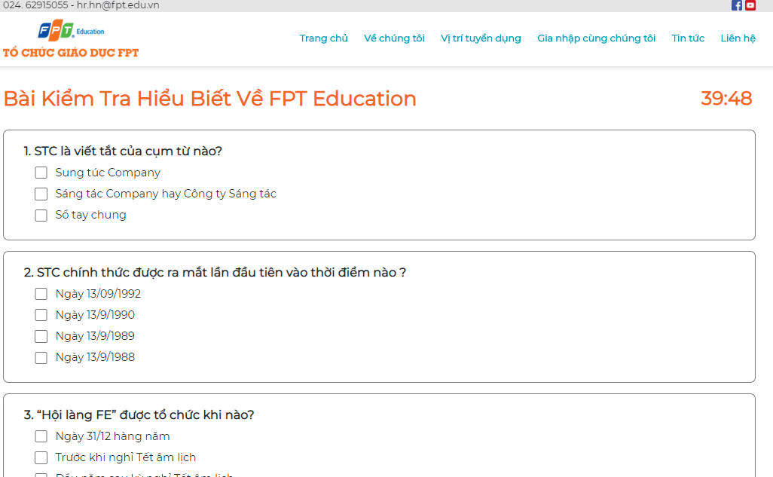

*Take quiz page*

***1.2. Login***

Go to url **: career.fpt.edu.vnAccount/Login** to go to the login page. Click the “Đăng nhập” button and select your email to login the system. After login success,

* If you have the role “HR Staff”, the system will redirect to the HR manager page.
* If you have role “Admin” or both role “Admin” and “HR Staff”, the system will redirect to the admin manage page.

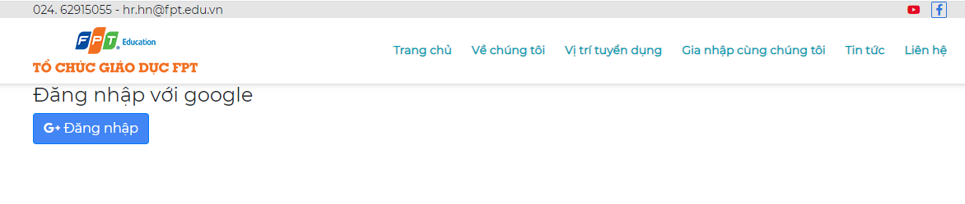

*Login page*

**1.3. Admin**

Description all about function of Admin

***1.3.1. Account management***

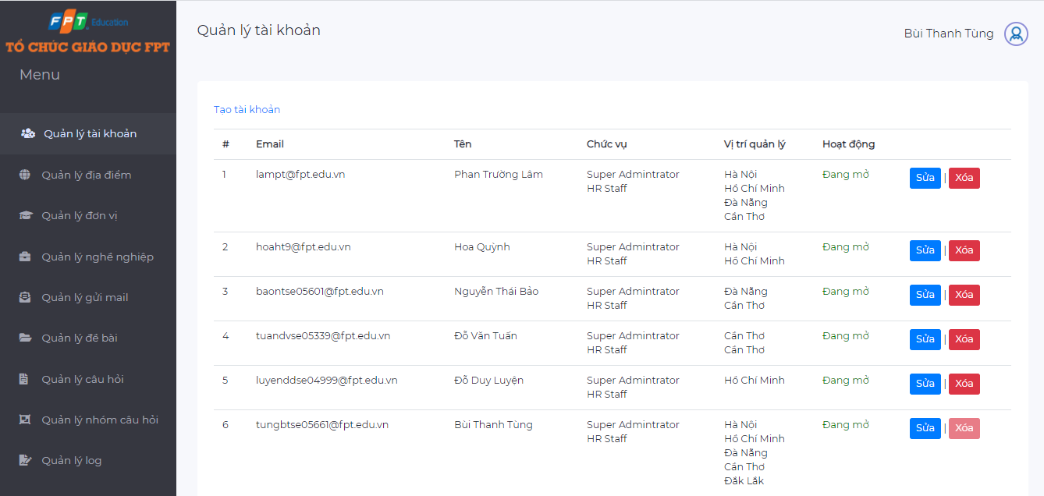

*Account management page*

This is the account management page. This page shows all accounts in the system.

* If you want to create a new account, click “Tạo tài khoản”.
* If you want to edit an account, click the “Sửa” button.
* If you want to delete an account, click the “Xóa” button.

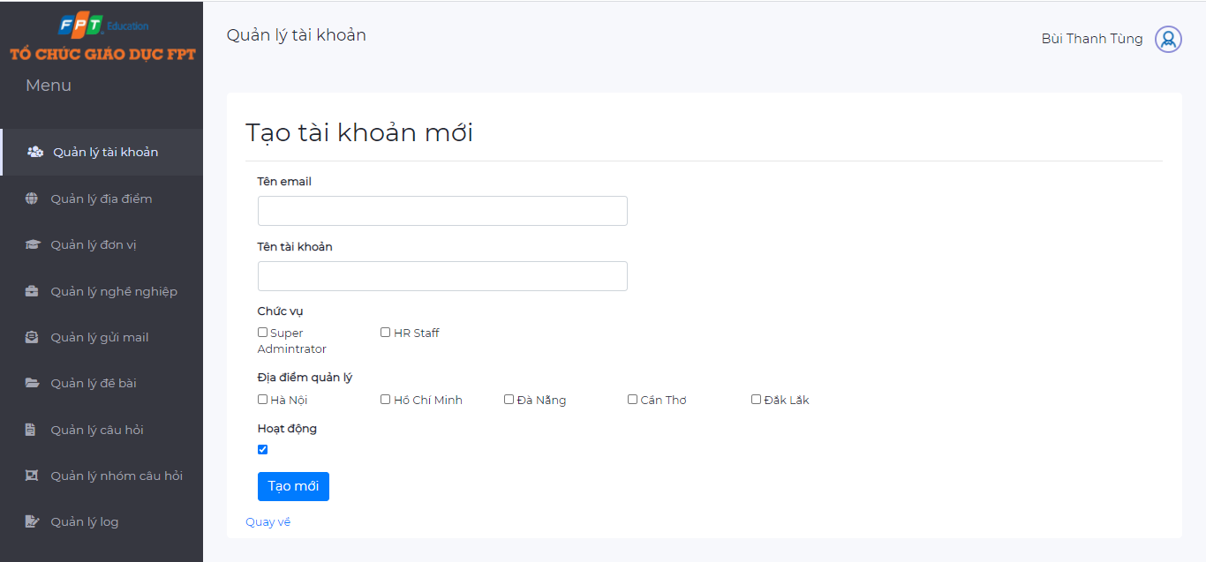

*Add account page*

* When user want to add a new account, they have to full fill the following information:
  + “Tên email”: email of the account
  + “Tên tài khoản”: Display name of the account
  + “Chức vụ”: Role of account, there are two role of accounts: **Super Administrator** and **HR Staff.**
  + “Địa điểm quản lý”: All working locations of FPT Education. The user only has management rights related to the specified locations
  + “Hoạt động”: Enable or disable the account?
* Similarly, with the edit account page, the user must also fill in the information as above

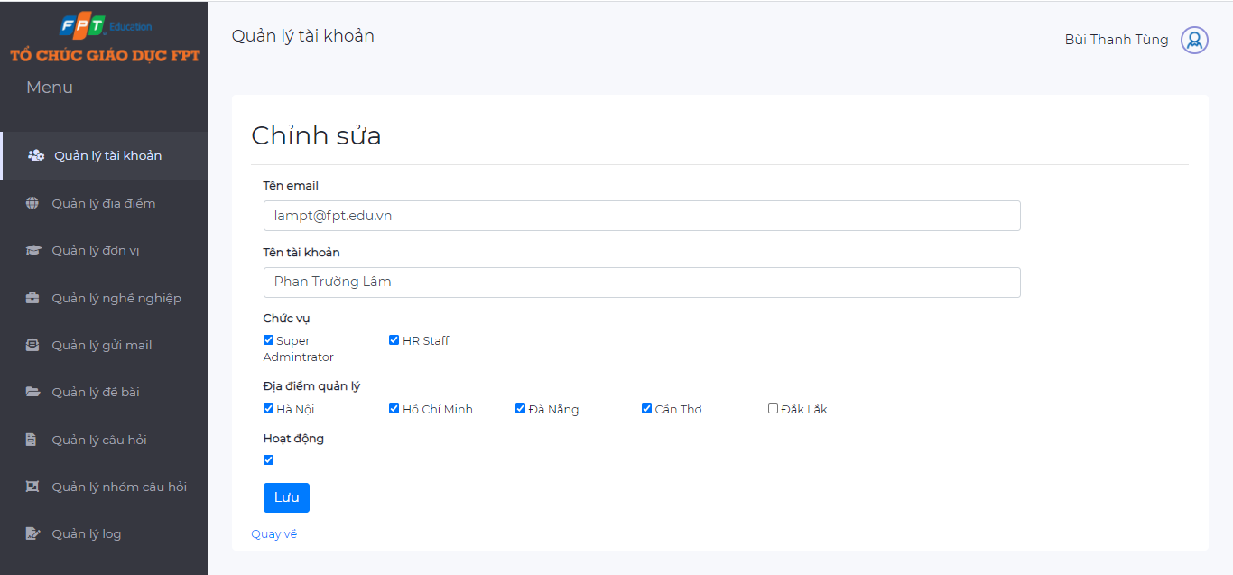

*Edit account page*

When the user wants to remove an account from the system, they can click the button “Xóa” on an account. A confirmation dialog will popup, if the user clicks OK - the account will be removed from the system.

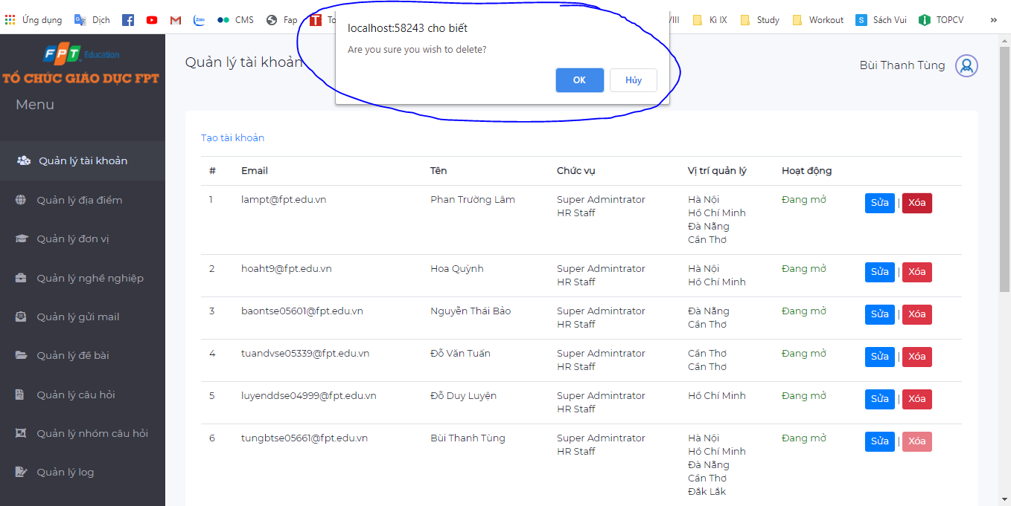

*Confirmation when deleting an account*

***1.3.2. Location management***

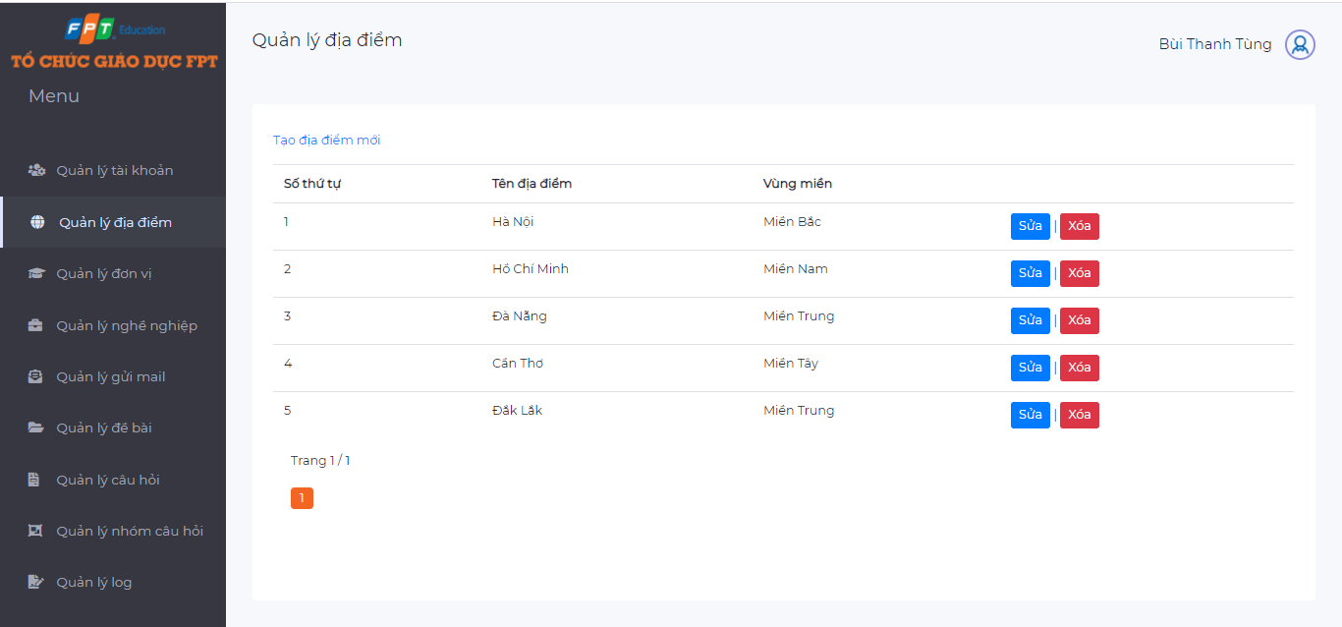

*Location management page*

This is a location management page. This page shows a list of all working locations of FPT Education.

* Click “Tạo địa điểm mới” to add a new location into FPT Education
* Click “Sửa” to edit a location
* Click “Xóa” to delete a location

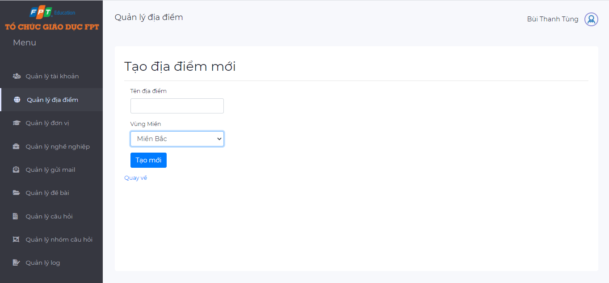

*Add location page*

* When adding a new location, user must full fill the following information:
  + “Tên địa điểm”: Name of the location
  + “Vùng miền”: Region of the location
* When editing the location, the user can change the name and region of the location.
* When deleting the location, a modal dialog will popup to make sure that the user really wants to delete the location.

***1.3.3. Unit management***

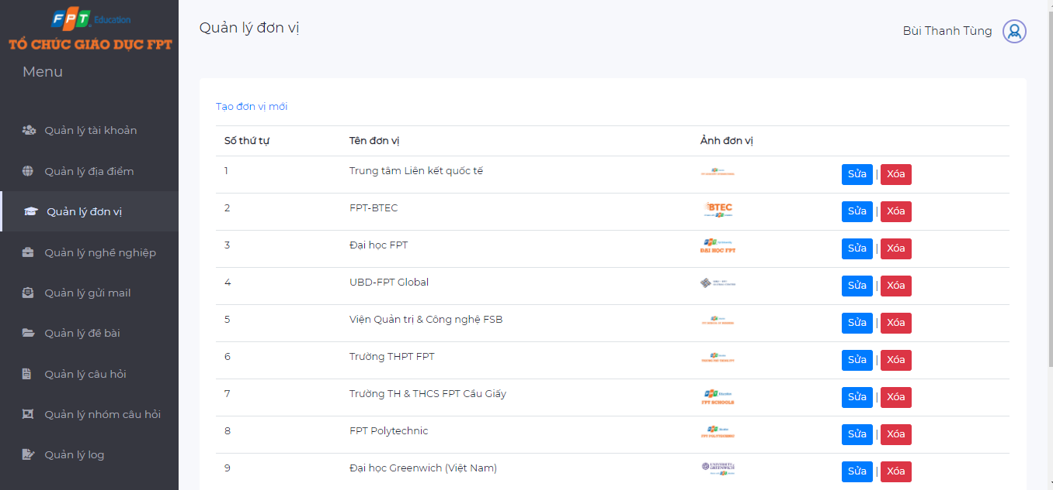

*Unit management page*

This is unit management page. This page shows list of all working units of FPT Education.

* Click “Tạo đơn vị mới” to add a new unit into FPT Education
* Click “Sửa” to edit a unit
* Click “Xóa” to delete a unit

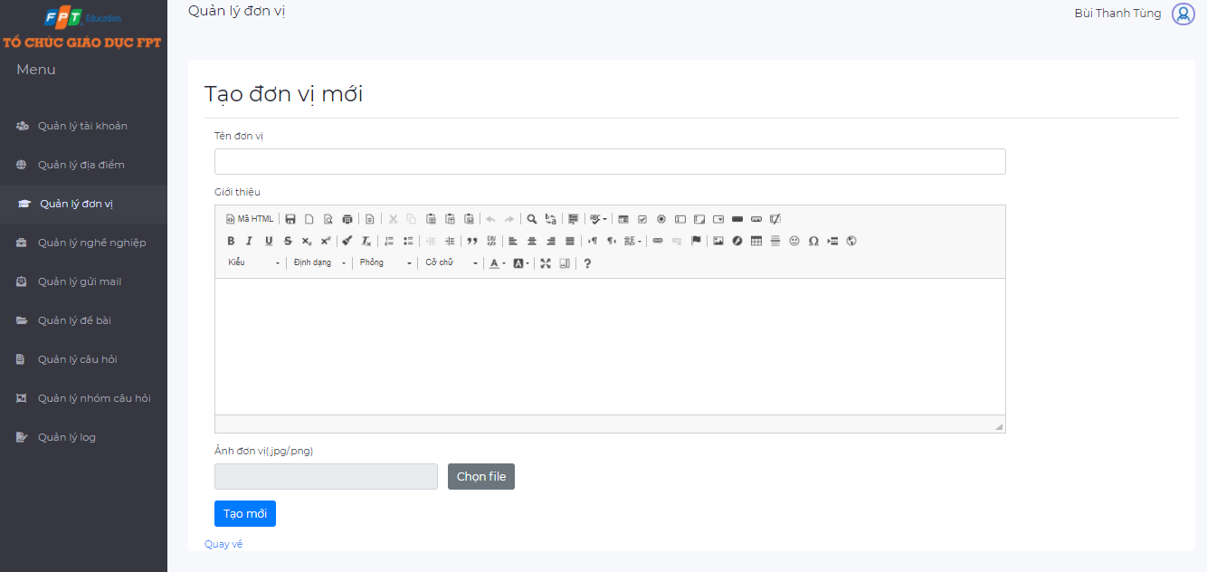

*Add unit page*

* When adding a new unit , user must full fill the following information:
  + “Tên đơn vị”: Name of the unit
  + “Giới thiệu”: Description about the unit
  + “Ảnh đơn vị”: A photo of the unit (must be JPG or PNG format file and below 4MB size)
* When editing the unit, the user can change the above information (unit name, description, image).
* When deleting the unit, a modal dialog will popup to make sure that the user really wants to delete the unit.

***1.3.4. Career management***

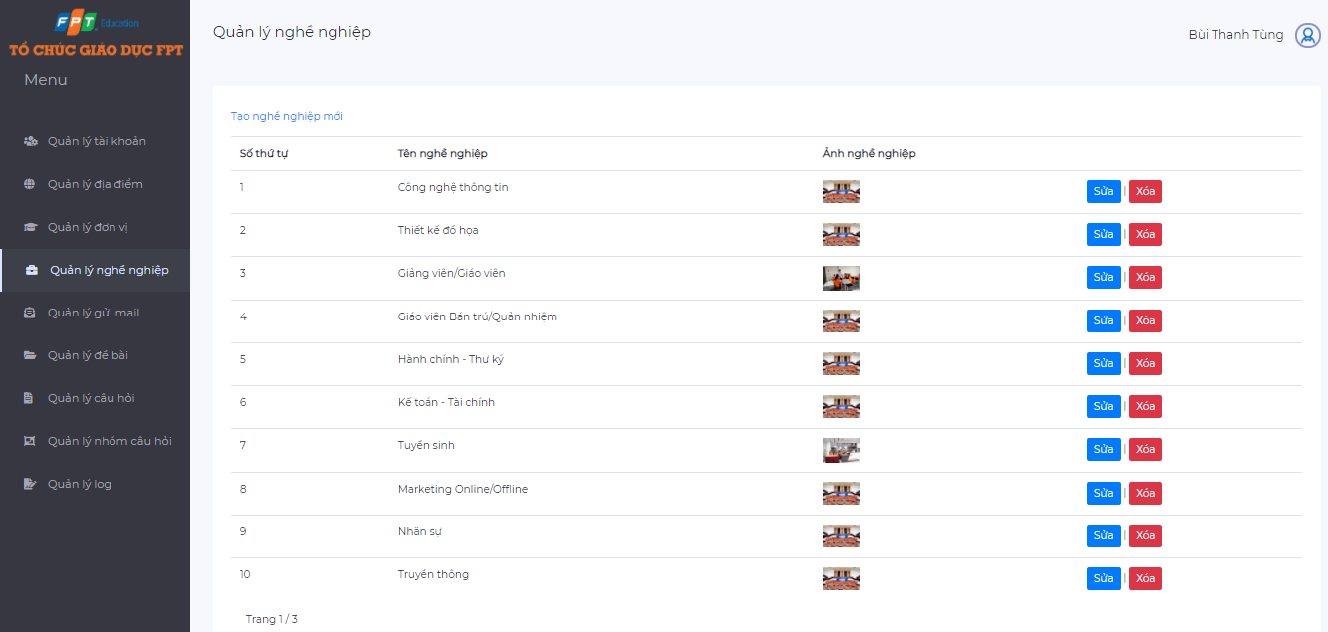

*Career management page*

This is a career management page. This page shows a list of all careers of FPT Education.

* Click “Tạo nghề nghiệp mới” to add a new career into FPT Education
* Click “Sửa” to edit a career
* Click “Xóa” to delete a career

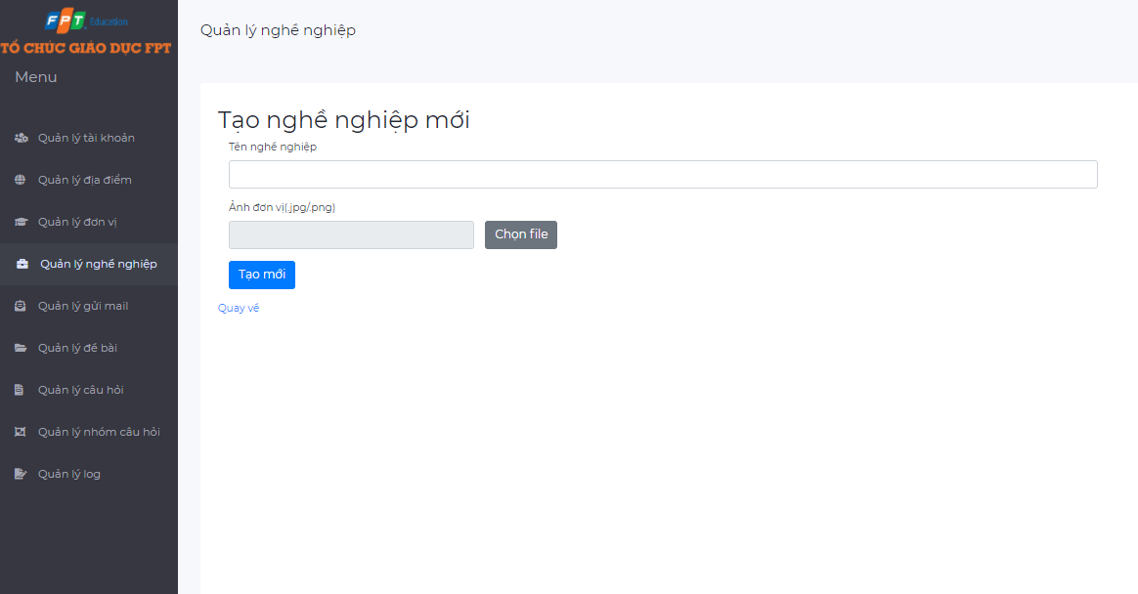

*Add career page*

* When adding a new career, user must full fill the following information:
  + “Tên nghề nghiệp”: Name of the career
  + “Ảnh nghề nghiệp”: A photo of the career (must be JPG or PNG format file and below 4MB size)
* When editing the career, the user can change the above information (career name, image).
* When deleting the career, a modal dialog will popup to make sure that the user really wants to delete the career.

***1.3.5. Config email management***

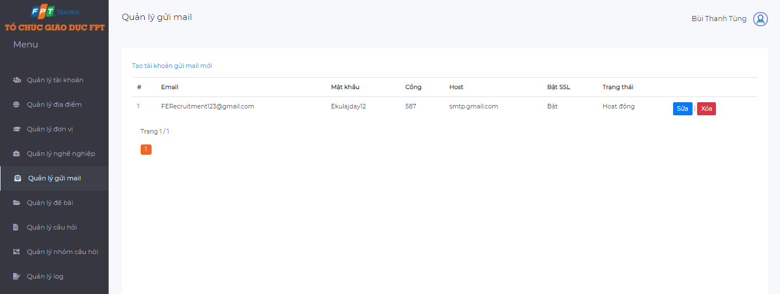

*Config email management page*

This is the config email management page. This page shows a list of all emails which are used to automatically send to the candidates .

* Click “Tạo tài khoản gửi mail mới” to add a new email
* Click “Sửa” to edit an email
* Click “Xóa” to delete an email

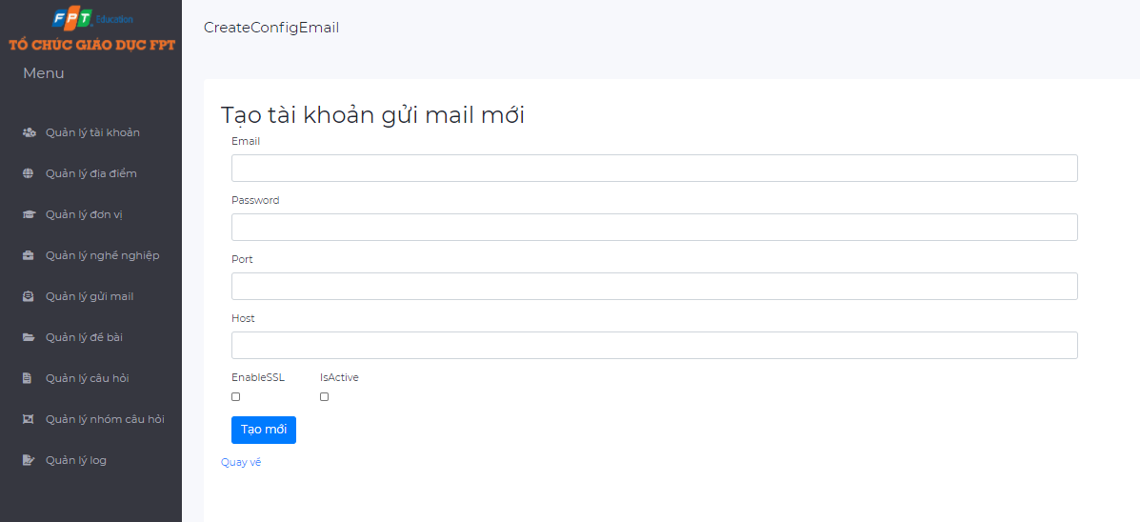

*Add a new email*

* When adding a new email, user must full fill the following information:
  + “Email”: The email address
  + “Password”: The password of the email address
  + “Port”:
  + “Host”:
  + “EnableSSL”:
  + “IsActive”: When this option is checked, the email is able to be used. Note that only one email is enabled at a time.
* When editing the email, the user can change the above information (email address, password, port number, host, enableSSL, isActive).
* When deleting the email, a modal dialog will popup to make sure that the user really wants to delete the email.

***1.3.6. Question management***

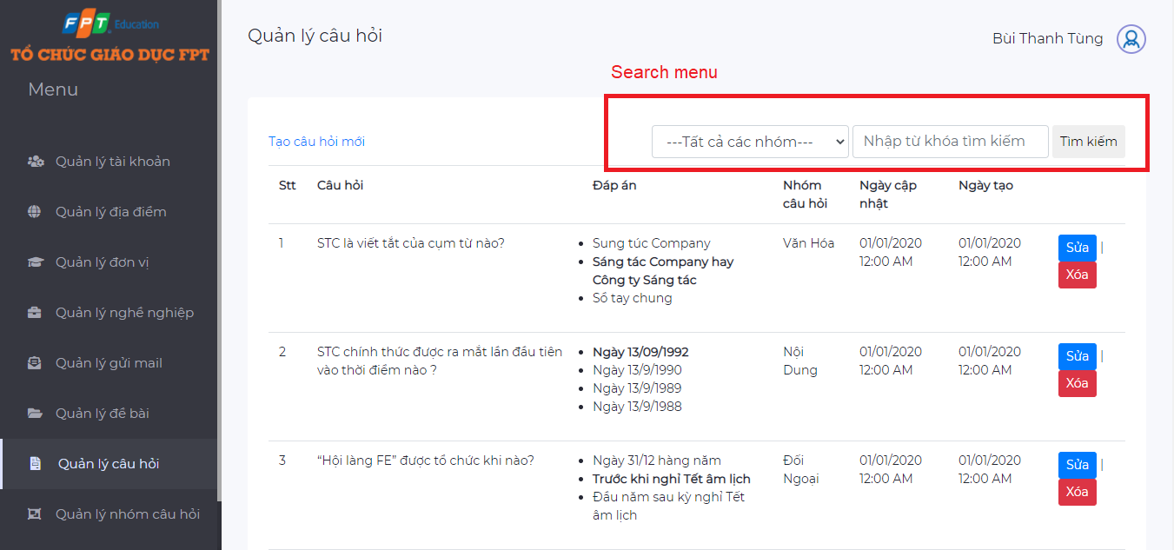

*Question management page*

The above is an interface of the question management page, including a list of all questions and search menu.

* Click “Tạo câu hỏi mới” to add a new question
* Click “Sửa” to edit a question
* Click “Xóa” to delete a question

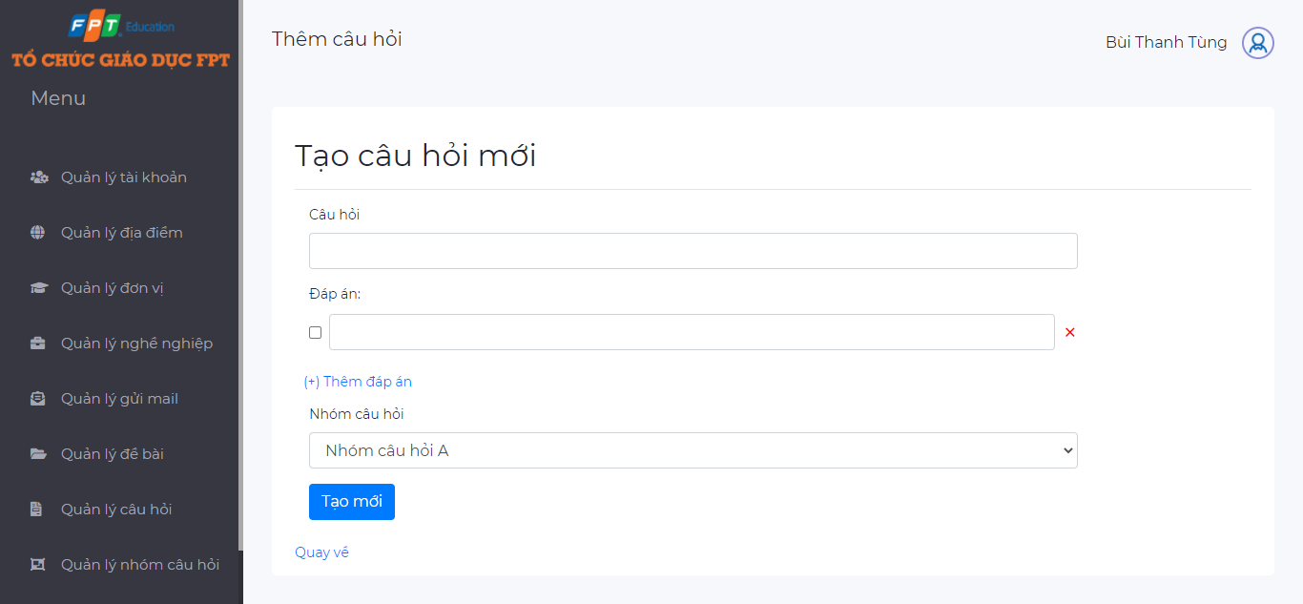

*Add question page*

* When adding a new question, user must full fill the following information:
  + “Câu hỏi”: Content of the question
  + “Đáp án”: Answers of the question. A question has one or more answers
  + User can add a new answer by clicking the button “Thêm đáp án”
  + “Nhóm câu hỏi”: The questions in the system are divided into groups to easily classify candidates
* When editing the question, the user can change the above information (question name, answers, question group)
* When deleting the question, a modal dialog will popup to make sure that the user really wants to delete it.

***1.3.7. Question group management***

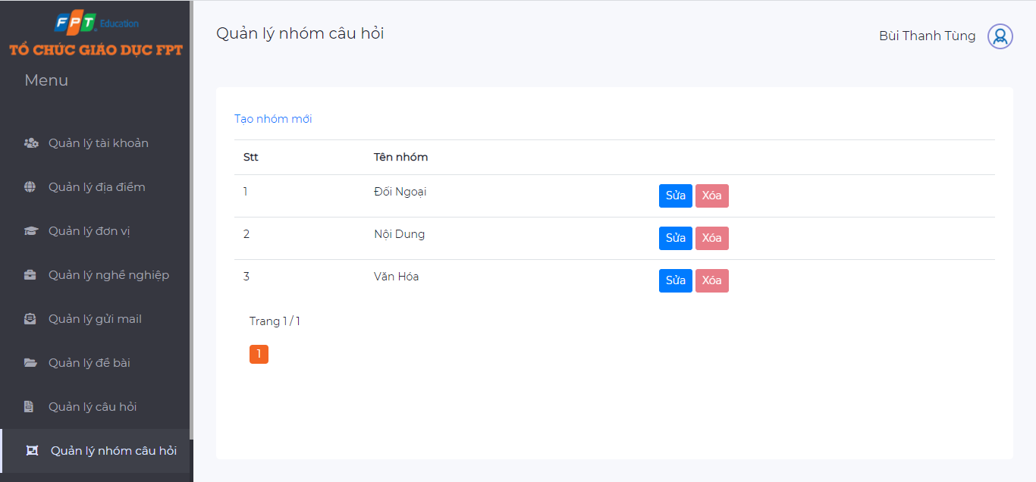

*Question group management page*

As mentioned above, the questions in the system will be divided into groups to easily manage the question bank and classify candidates when doing tests.

* Click “Tạo nhóm mới” to add a new question group
* Click “Sửa” to edit a question group
* Click “Xóa” to delete a question group

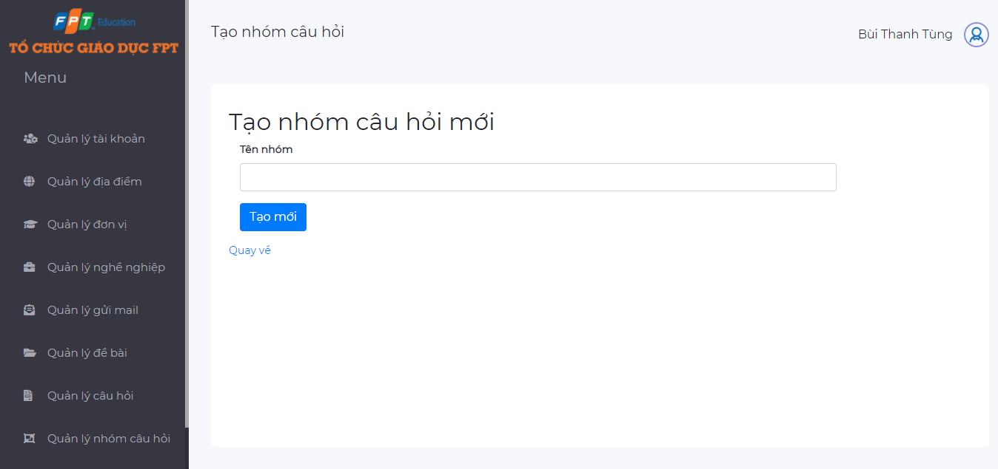

*Add question group page*

* When adding a new question group, user must full fill the following information:
  + “Tên nhóm”: The question group name
* User can also edit the name of question group
* Note: When creating a new question group, by default this question group has **no questions**, but once **a question is added to this group**, **it cannot be deleted**.

***1.3.8. Quiz management***

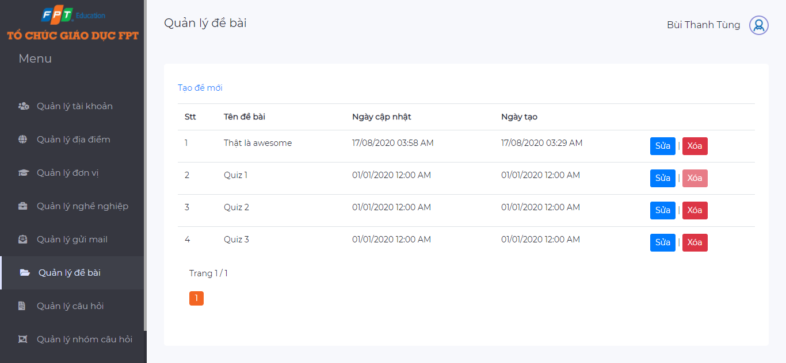

*Quiz management page*

Quiz is a collection of questions that will be selected by Super Admin.

* Click “Tạo đề bài mới” to add a new quiz
* Click “Sửa” to edit a quiz
* Click “Xóa” to delete a quiz

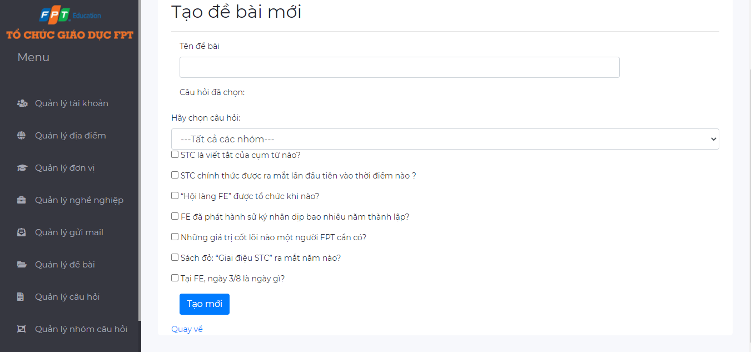

*Add quiz page*

* When adding a new quiz, user must full fill the following information:
  + “Tên đề bài”: The quiz name
  + Questions: Users select the questions by clicking the check box. The list of questions can be displayed all or filtered by question group
* User can also edit the name of quiz or the questions of the quiz
* When deleting a quiz, there is one thing to note that, it is not possible to delete the quizzes for which the candidate has already taken.

***1.3.9. Log management***

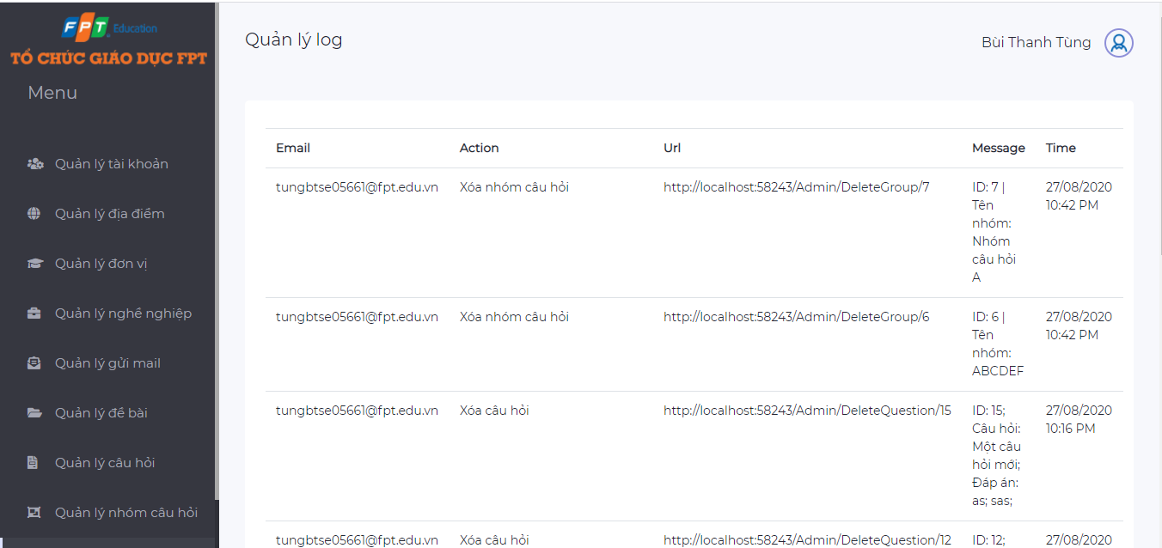

*Log management page*

When there are changes made to the system, the change history is logged and displayed in the log page.

For example: When a HR Staff deletes a question in question bank, this action is logged including information like: who took the action, type of action, url, message of action, datetime of action.

**1.4. HR Staff**

***1.4.1. Job management***

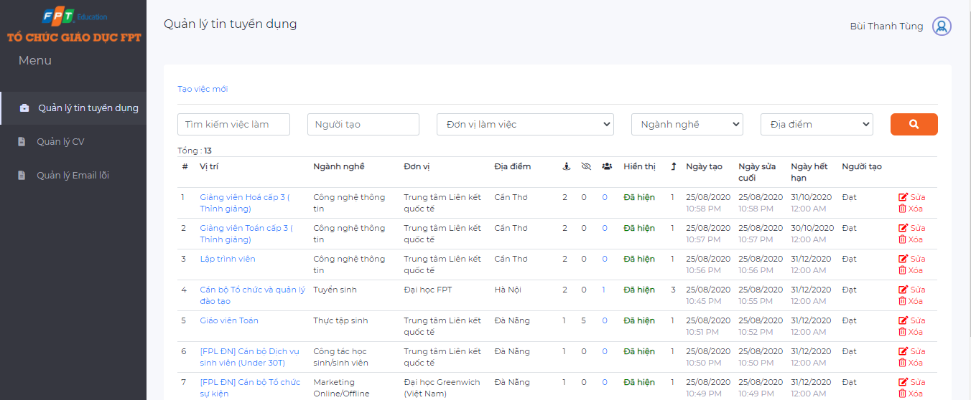

The above is job management page, display all information about jobs that are in recruitment need

* “Vị trí”: Position of recruitment job
* “Ngành nghề”: The major involve to the job
* “Đơn vị”: The unit
* “Địa điểm”: Working location
* “Số lượng cần tuyển”: Number of recruitment required
* “Lượt xem”: Number of clicks on job details
* “Số lượng CV đã ứng tuyển”: Number of CV applied to the job, user can click this to see list of all CVs that applied for this job
* “Hiển thị”: Are the jobs currently displayed?
* “Độ ưu tiên”: There are 3 priority levels (1, 2 and 3). The higher the priority level, the first displayed job on the homepage
* “Ngày tạo”: The created date
* “Ngày sửa cuối”: Datetime of last modified
* “Người tạo”: Who created this job

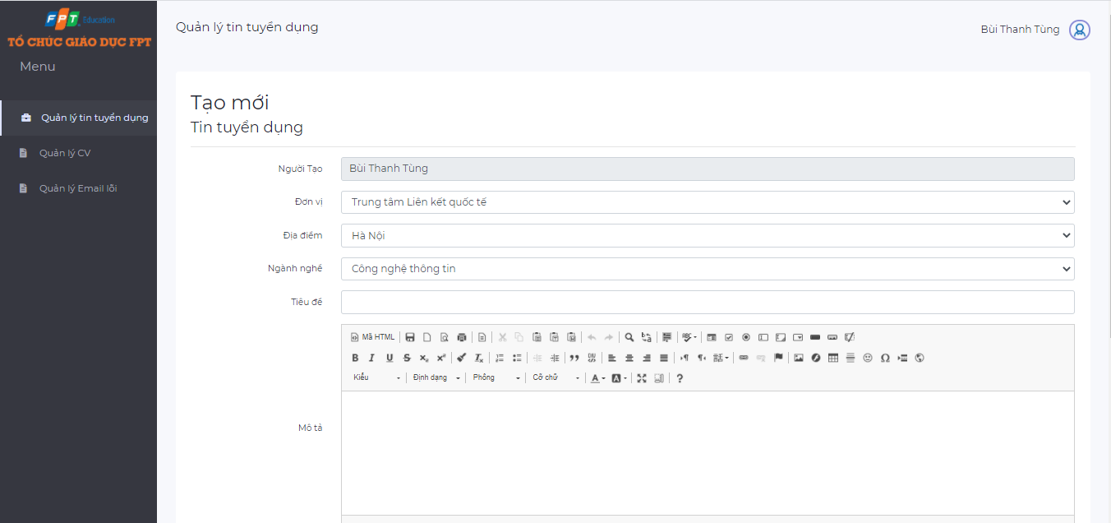

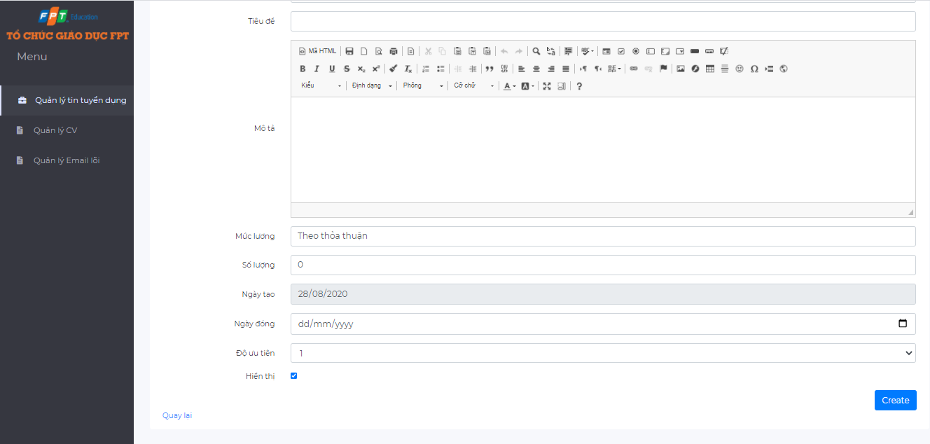

*Add job page*

When adding or editing the job, user must full fill the following information:

* “Đơn vị”: working unit
* “Địa điểm”: working location
* “Ngành nghề”: major of the job
* “Tiêu đề”: title of the job
* “Mô tả”: description about the job
* “Mức lương”: amount of salary
* “Số lượng”: number to be recruited
* “Ngày tạo”: created date
* “Ngày đóng”: close date
* “Độ ưu tiên”: priority level (1, 2, 3)
* “Hiển thị”: enable this option to show job, when you disable this option, the job will not display at candidate side.

***1.4.2. CV management***

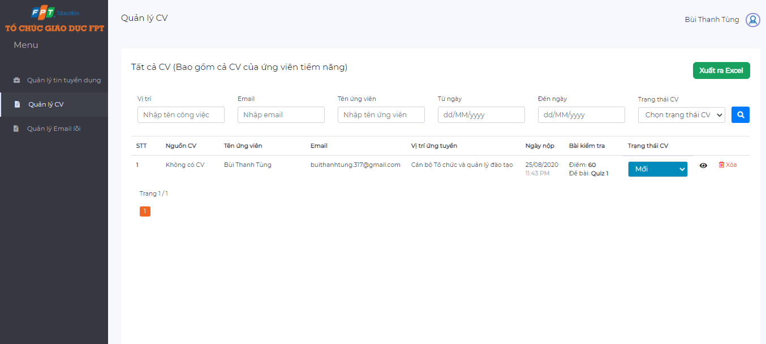

*Cv management page*

The above is CV management page, show list of all CVs that was submitted to the system

* Click the eye icon to view detailed information about CV
* Search a CV by job position, email, candidate name, date, status of CV
* Change status of CV, there are five status of CV:
  + New
  + Seen
  + Considering
  + Approve
  + Reject
* Send link quiz for candidates

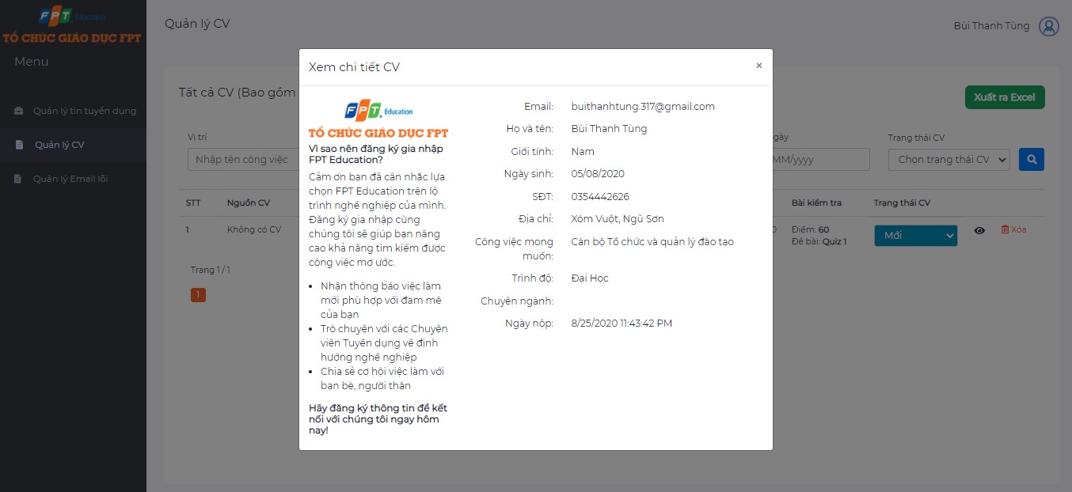

*Detail CV*

***1.4.3. Error email management***

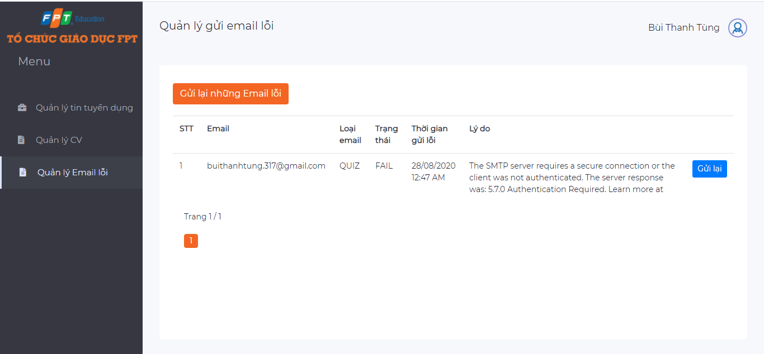

*Error email management page*

When sending emails to candidates, the email may not reach the candidate's inbox due to some error, such as the access network does not allow sending mail, lost internet connection, ..... These emails are not lost but are saved in the system and displayed on the error email management page.

HR Staff can select a certain error email to resend by clicking the button “Gửi lại”. Can also resend all the error emails by clicking “Gửi lại những Email lỗi”